**Little Big Horn College and its 6 Peer Colleges**

LBHC selected three regional tribal colleges – Blackfeet Community College, Fort Peck Community College, and Stone Child College (all located in Montana) – and three national tribal colleges– Bay Mills Community College (Michigan), College of the Muscogee Nation (Oklahoma), and Lac Courte Oreilles Ojibwe College (Wisconsin) – for peer comparisons. See the [American Indian Higher Education Consortium map](https://www.aihec.org/tcu-locations/) for the location of these colleges.

These peer colleges are, most importantly, comparable to LBHC in their mission – they are all tribal colleges with a mission to preserve, protect, and perpetuate their tribal language, history, and culture. These peer colleges are also similar to LBHC in size, student demographics, budget, and professional-technical/transfer mix.

IPEDS was the only available source of data for comparing retention and graduation rates with LBHC’s peer colleges. Data were downloaded from [IPEDs](https://nces.ed.gov/ipeds/datacenter/InstitutionByName.aspx?goToReportId=5&sid=798a7318-0592-4f9a-8c83-22e2741a5c52&rtid=5) on November 26, 2023.

**Peer colleges FTE**

|  |  |  |  |
| --- | --- | --- | --- |
| College | Peer | State | FTE undergraduate 2020-21 |
| Little Big Horn College |  | MT | 267 |
| Bay Mills Community College | National | MI | 318 |
| Blackfeet Community College | Regional | MT | 186 |
| College of the Muscogee Nation | National | OK | 191 |
| Fort Peck Community College | Regional | MT | 321 |
| Lac Courte Oreilles Ojibwe College | National | WI | 182 |
| Stone Child College | Regional | MT | 233 |

**First-time full-time adjusted fall cohort**

|  |  |  |  |  |  |  |  |  |  |  |
| --- | --- | --- | --- | --- | --- | --- | --- | --- | --- | --- |
|  | 2012 | 2013 | 2014 | 2015 | 2016 | 2017 | 2018 | 2019 | 2020 | 2021 |
| Little Big Horn College | 17 | 47 | 73 | 37 | 69 | 54 | 57 | 70 | 63 | 36 |
| Bay Mills Community College | 112 | 94 | 92 | 84 | 57 | 60 | 0 | 4 | 2 | 4 |
| Blackfeet Community College | 73 | 93 | 91 | 98 | 62 | 63 | 54 | 61 | 77 | 66 |
| College of the Muscogee Nation |  | 40 | 33 | 41 | 55 | 51 | 51 | 65 | 59 | 54 |
| Fort Peck Community College | 75 | 63 | 40 | 45 | 45 | 45 | 45 | 42 | 59 | 45 |
| Lac Courte Oreilles Ojibwe University | 33 | 60 | 37 | 46 | 25 | 27 | 24 | 19 | 6 | 3 |
| Stone Child College | 34 | 31 | 43 | 37 | 40 | 42 | 4 | 2 | 6 | 1 |
| Average peer colleges | 327 | 381 | 336 | 351 | 284 | 288 | 178 | 193 | 209 | 173 |

**Fall-to-fall retention rates for first time full-time students (%)**

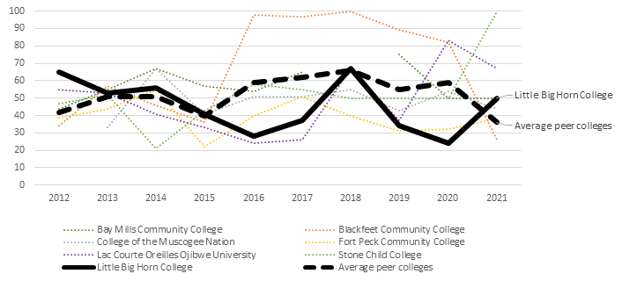

|  |  |  |  |  |  |  |  |  |  |  |
| --- | --- | --- | --- | --- | --- | --- | --- | --- | --- | --- |
|  | 2012 | 2013 | 2014 | 2015 | 2016 | 2017 | 2018 | 2019 | 2020 | 2021 |
| Little Big Horn College | 65% | 53% | 56% | 41% | 28% | 37% | 67% | 34% | 24% | 50% |
| Bay Mills Community College | 44% | 55% | 67% | 57% | 54% | 65% | - | 75% | 50% | 50% |
| Blackfeet Community College | 34% | 57% | 46% | 36% | 98% | 97% | 100% | 89% | 82% | 26% |
| College of the Muscogee Nation | - | 33% | 67% | 41% | 51% | 51% | 55% | 43% | 54% | 44% |
| Fort Peck Community College | 39% | 44% | 55% | 22% | 40% | 51% | 40% | 31% | 32% | 38% |
| Lac Courte Oreilles Ojibwe University | 55% | 53% | 41% | 33% | 24% | 26% | 67% | 37% | 83% | 67% |
| Stone Child College | 47% | 52% | 21% | 43% | 58% | 55% | 50% | 50% | 50% | 100% |
| Average peer colleges | 42% | 51% | 51% | 40% | 59% | 62% | 66% | 55% | 59% | 36% |

*Observation*: LBHC’s fall-to-fall retention rate is within the lower range of its [peer colleges](http://lbhc.edu/sites/default/files/lbhc/Accreditation2023/data_2012_2013/LBHC-PeerColleges.pdf) (see the graphs above). The small student populations result in fluctuating rates from year-to-year, so LBHC compared itself to the average of its peer colleges.

**Graduation rate (%) for first time full-time students - within 150% of normal time**

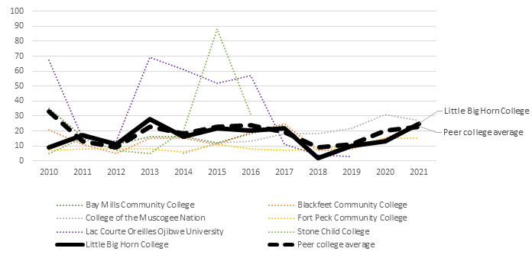

|  |  |  |  |  |  |  |  |  |  |  |  |  |
| --- | --- | --- | --- | --- | --- | --- | --- | --- | --- | --- | --- | --- |
|  | 2009 | 2010 | 2011 | 2012 | 2013 | 2014 | 2015 | 2016 | 2017 | 2018 | 2019 | 2020 |
| Little Big Horn College | 9% | 17% | 11% | 28% | 16% | 22% | 20% | 22% | 2% | 10% | 13% | 25% |
| Bay Mills Community College | 35% | 16% | 11% | 16% | 16% | 12% | 18% | 24% | - | - | - | - |
| Blackfeet Community College | 21% | 11% | 5% | 15% | 15% | 11% | 19% | 25% | 7% | 8% | 15% | 25% |
| College of the Muscogee Nation | - | - | - | - | 5% | 12% | 13% | 18% | 18% | 22% | 31% | 27% |
| Fort Peck Community College | 7% | 8% | 8% | 8% | 6% | 11% | 8% | 7% | 8% | 10% | 15% | 15% |
| Lac Courte Oreilles Ojibwe University | 67% | 15% | 13% | 69% | 61% | 52% | 57% | 11% | 4% | 3% | - | - |
| Stone Child College | 5% | 15% | 7% | 5% | 20% | 88% | 31% | - | - | - | - | - |
| Peer college average | 33% | 13% | 9% | 23% | 18% | 23% | 24% | 19% | 9% | 11% | 20% | 23% |

*Observation*: LBHC’s 3-year graduation rate is almost identical to the average of its [peer colleges](http://lbhc.edu/sites/default/files/lbhc/Accreditation2023/data_2012_2013/LBHC-PeerColleges.pdf) (see the graphs above). The small student populations result in fluctuating rates from year-to-year, so LBHC compared itself to the average of its peer colleges.